Fool Moon Grill and Bar
West

5625 Pearl Dr. Suite G
Wrap/Sandwich Platter: $6/wrap/sandwich

$5.5/wrap/sandwich when ordering 20 or more
Chicken Salad Wrap: Chicken salad (contains nuts) lettuce, cheese
Chicken Caesar Wrap: Grilled chicken, lettuce, parmesan cheese, Caesar dressing
California Wrap: Turkey, bacon, lettuce, feta cheese, pineapple
Turkey Club Wrap: Turkey, ham, bacon, cheese, lettuce
Chicken Bacon Ranch Wrap: Grilled Chicken, bacon, lettuce, cheese, ranch
Veggie Wrap available upon request

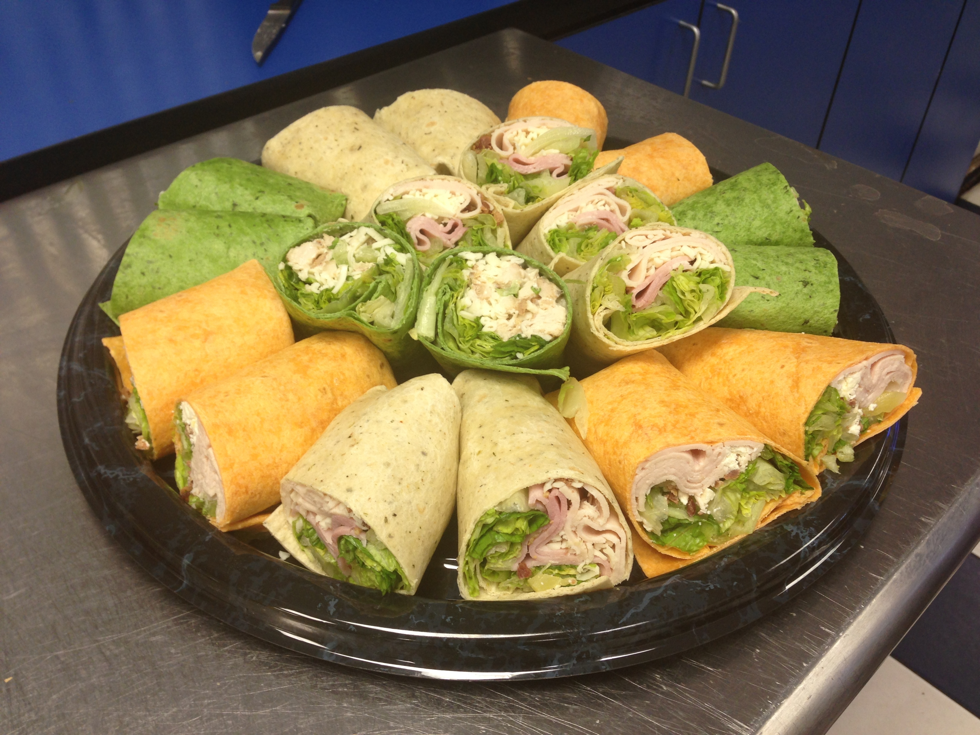
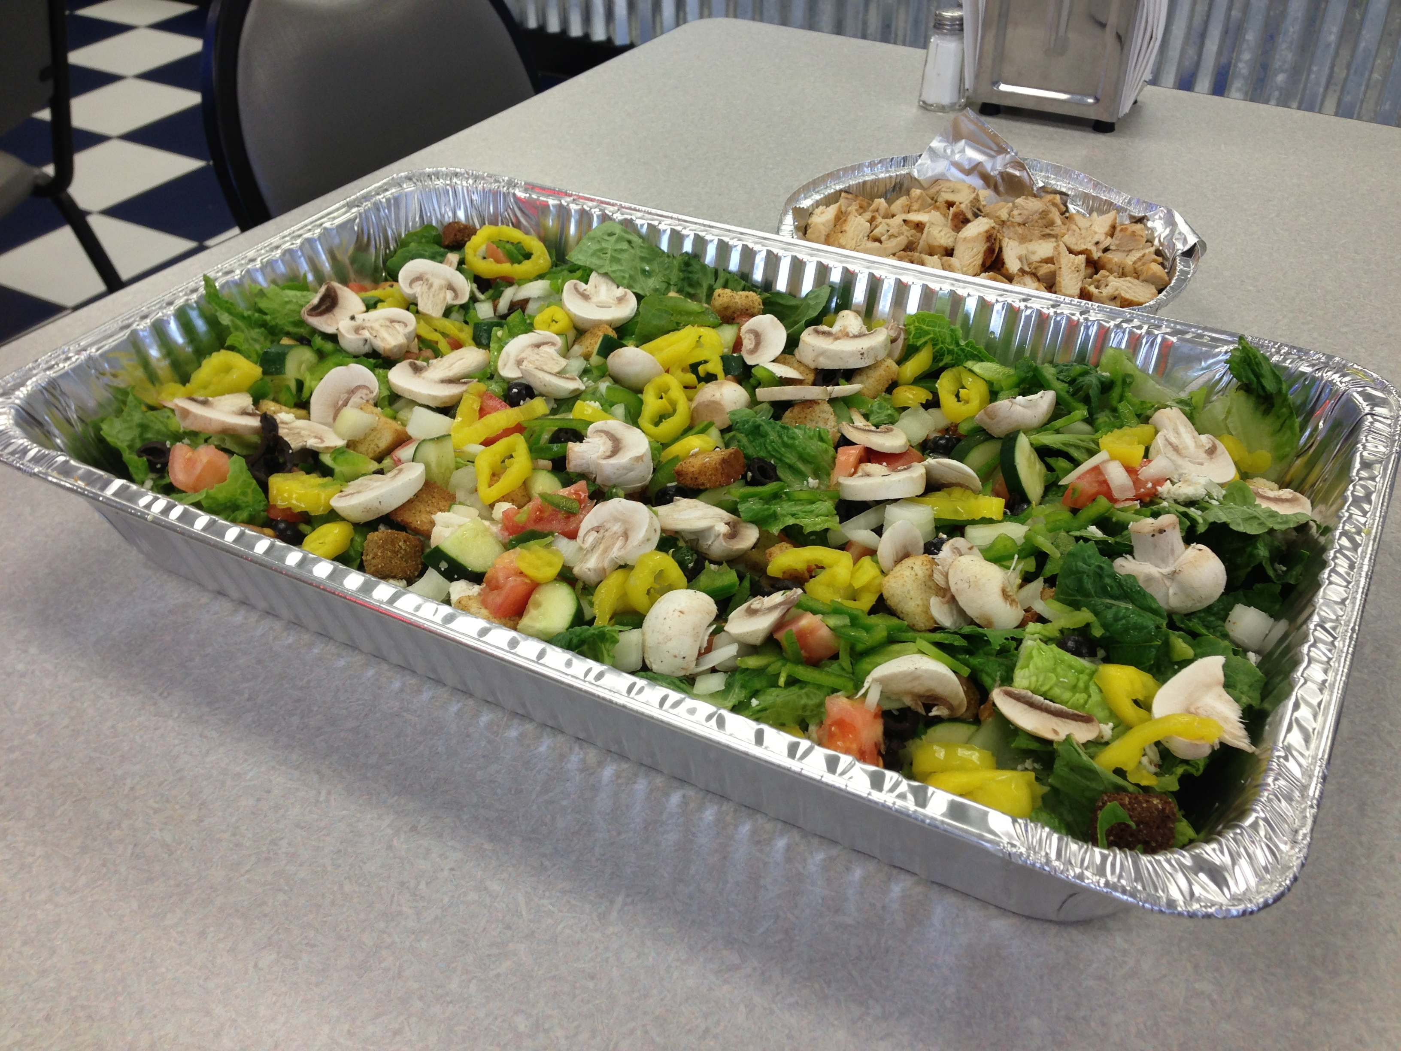
Salads Also available

Call Ryan for more information!
467-7486
Delivery available with 24 hour notice

